**Resource groups:**

* You can use *resource groups* to organize your AWS resources. Resource groups make it easier to manage and automate tasks on large numbers of resources at one time. This guide shows you how to create and manage resource groups in AWS Resource Groups.

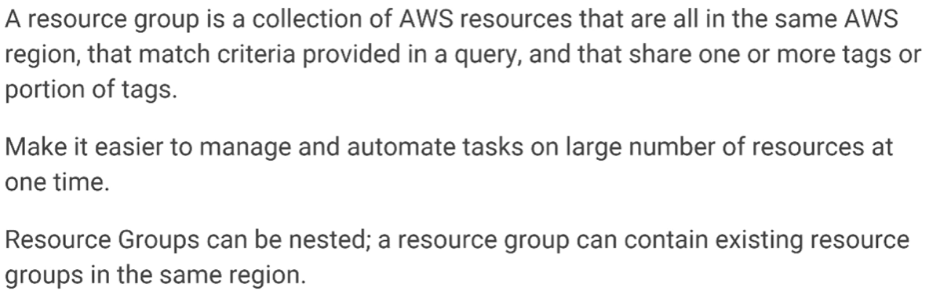

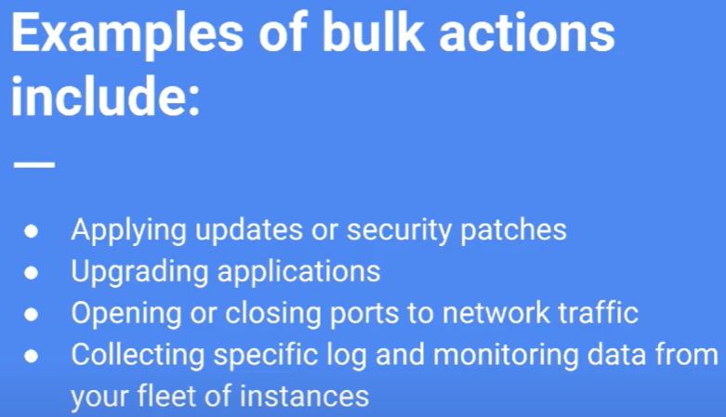

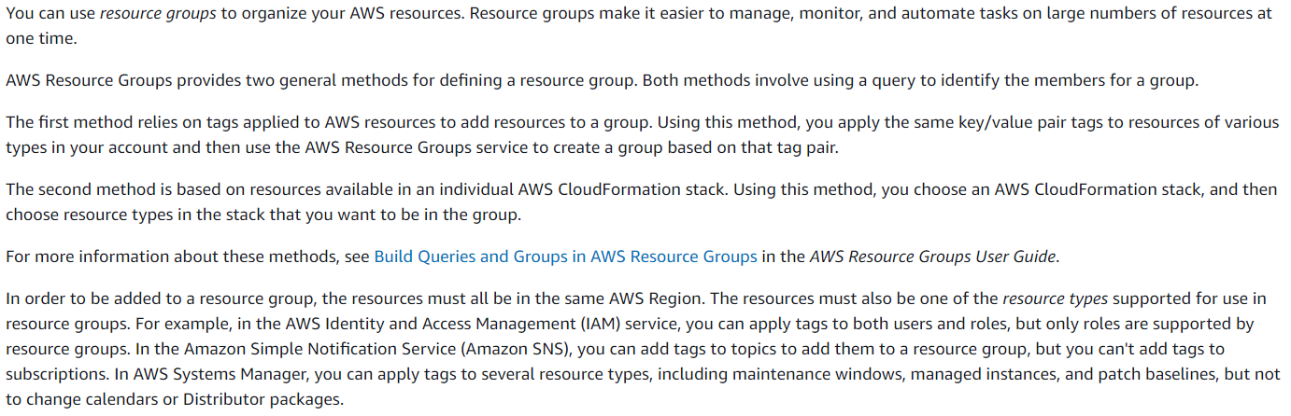

* Before we create resource group, we need to create tags.

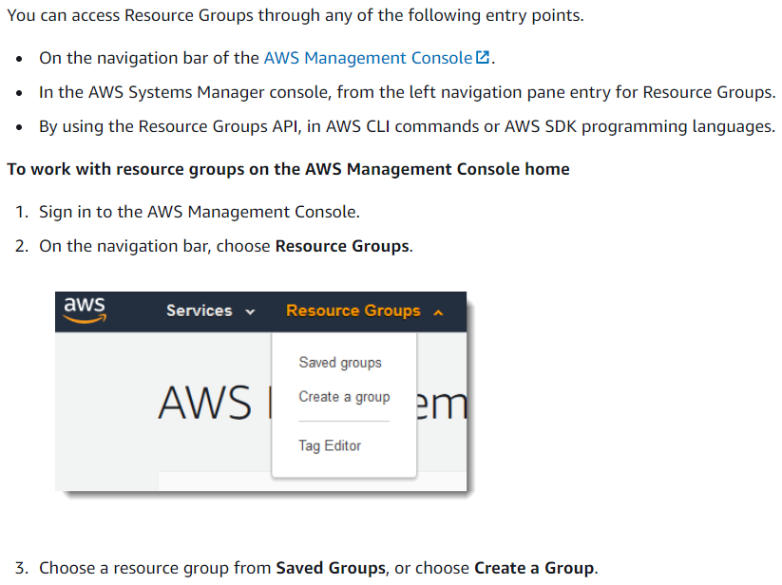

**Hands on:**

* We can select the option to create resource group from the AWS main page.

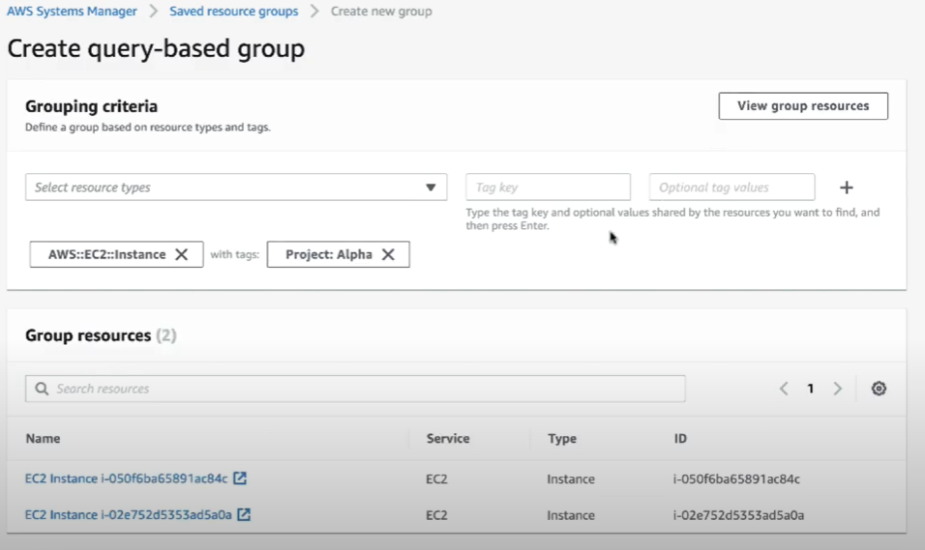

* We need to select the resource type and give the tags to get with which we want to filter the resources.
* As above, we have selected EC2 instances as resource types and alpha as tags. Click on view group resources after giving the tag. It will display the resources down below as above.
* After this, we need to give name and description for the group as below.

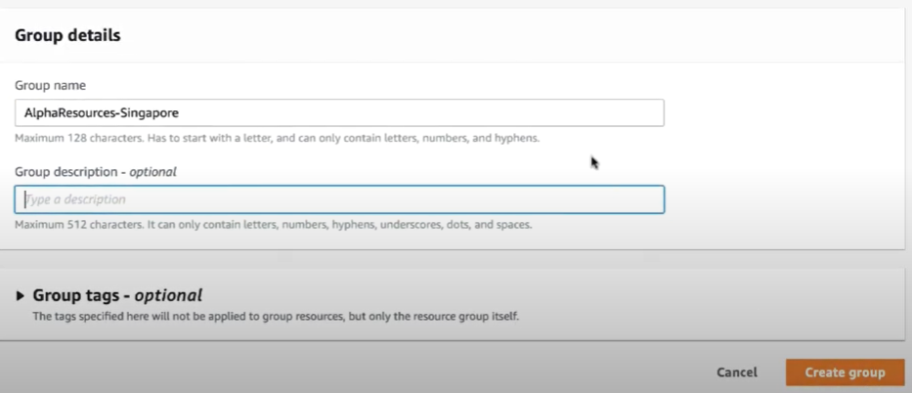

* we can also add tags for the group.
* Without tags, the resource groups can not be managed. It is very important to tag the resources.

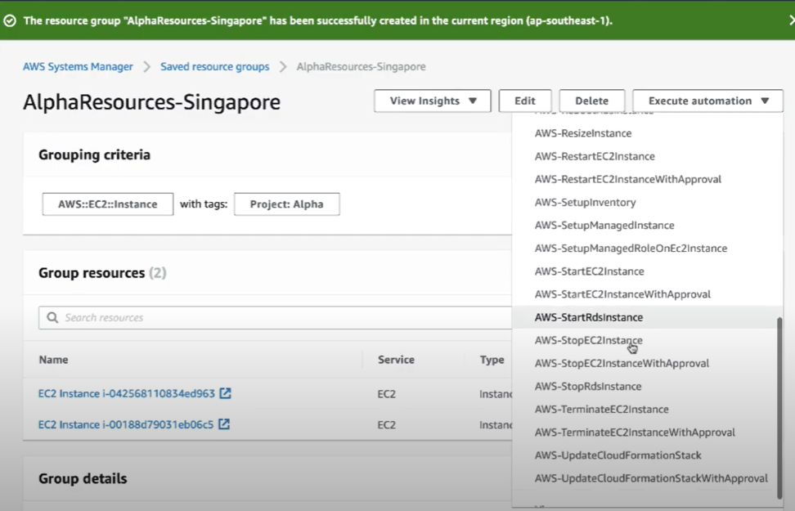

* Once the group is created. We can do some automation tasks using the “execute automation” option as above.
* If we select stop EC2 instance option. It will take to the automation step.

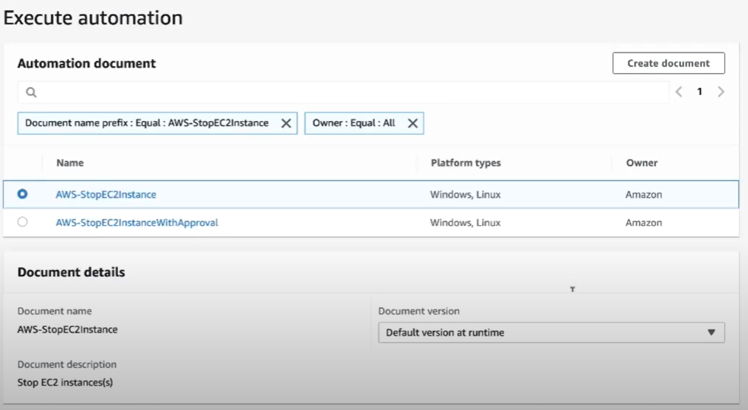

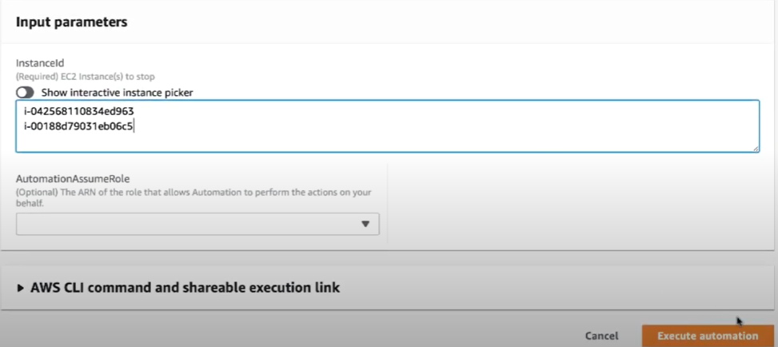

* Under input parameters, we need to give the instance IDs which we need to stop from the resource group as above.
* Once we execute the automation. We can see the given instances getting stopped.

**The main advantage of the resource group is that we can perform any action on multiple resources at a time or simply we can view the resources on dashboard at a time.**